Chapter 7 Farrell Program 21

Program 21 Code & Execution

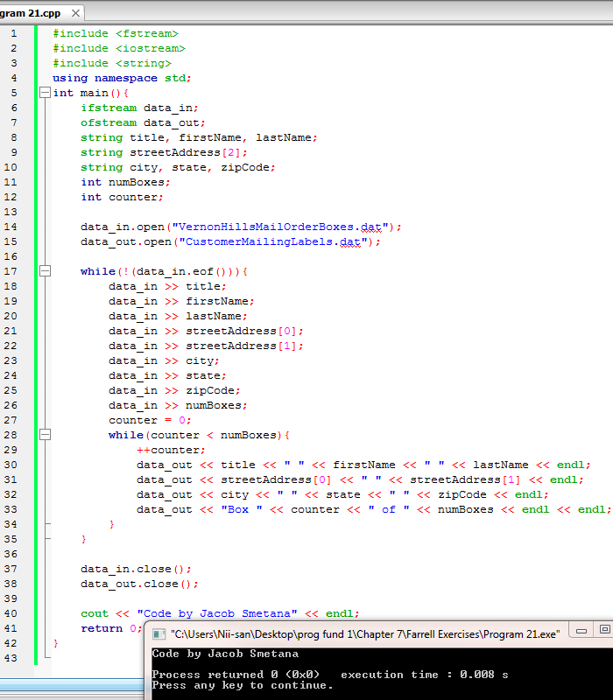

Program 21 Output

